SIMATS ENGINEERING
ASSESSMENT TOOL 1

COURSE NAME: INTERNET PROGRAMMING
COURSE CODE: CSA4307

COURSE OUTCOME COVERED

CO-2 : Apply CSS layout and styling techniques to create visually appealing and responsive web interfaces, and use JavaScript to enable interactive client-side behavior. (L3)

Assessment Tool : Integrated Experiments

Weightage: 40%

QUESTIONS: Total Marks: 30

Code of Conduct:

I PINDIBOINA SAI DEEPAK (Name / Reg No) certify that this submission is my original work and that I have adhered to the guidelines specified for this assessment. I understand that any violation of academic integrity rules will result in disciplinary action.

Signature of the student: Sai Deepak

Experiment 1: Responsive Layout Design
Suppose that a retail website is not responsive across mobile and tablet devices, causing misalignment of content and improper spacing.
(a) Analyze the possible reasons for lack of responsiveness in the existing layout.
(b) Design a responsive webpage layout using CSS Flexbox or Grid, ensuring proper alignment of header, navigation, content, and footer.
(c) Demonstrate how the layout adapts to different screen sizes (mobile, tablet, desktop) using media queries.
(d) Implement spacing, alignment, and distribution techniques to improve visual consistency.
(e) Evaluate the effectiveness of the responsive design and suggest further improvements.

Aim: To analyze responsiveness issues in a retail website and design a responsive webpage using CSS Grid, media queries, spacing, alignment, and distribution techniques.
(a) Analyze the possible reasons for lack of responsiveness
A website is considered responsive when its layout adjusts automatically to different screen sizes, including mobile phones, tablets, and desktop computers. A retail website may become misaligned when its CSS is designed only for large screens.
The possible reasons are:
- Fixed widths: Elements using fixed pixel widths may exceed the available screen width on mobile devices.
- Missing media queries: Without suitable media queries, the layout cannot adapt to different viewport sizes.
- Improper positioning: Excessive use of absolute positioning can cause elements to overlap when the screen is resized.
- Incorrect spacing: Inconsistent margins and padding can cause uneven alignment and unnecessary whitespace.
- Images exceeding the container: Large images may extend beyond their parent elements.
- Missing viewport configuration: Without the viewport meta tag, mobile browsers may not display the page at the intended device width.
- Poor navigation design: Navigation items may overflow instead of wrapping or stacking on smaller screens.
These problems can be reduced by using CSS Grid or Flexbox, responsive images, flexible widths, consistent spacing, and media queries.

(b) Design a responsive webpage using CSS Grid
The following HTML and CSS code creates a retail webpage with a header, navigation bar, product section, and footer. CSS Grid arranges the products in columns, while media queries adapt the layout to different screen sizes.
Program 1: experiment1.html

<!DOCTYPE html>
<html>
<head>
<style>
body { font-family: Arial; text-align: center; }
header, footer { background: lightblue; padding: 10px; }
main { display: flex; gap: 10px; }
.box { border: 1px solid gray; padding: 15px; flex: 1; }
@media(max-width: 500px) {
main { flex-direction: column; }
}
</style>
</head>
<body>

<header><h2>My Mini Store</h2></header>
<h3>Our Products</h3>

<main>
<div class="box">
<h3>Soap</h3>
<p>₹30</p>
<button onclick="add(30)">Add to Cart</button>
</div>
<div class="box">
<h3>Shampoo</h3>
<p>₹80</p>
<button onclick="add(80)">Add to Cart</button>
</div>
<div class="box">
<h3>Biscuits</h3>
<p>₹20</p>
<button onclick="add(20)">Add to Cart</button>
</div>
</main>

<h3>Cart: <span id="count">0</span> items</h3>
<h3>Total: ₹<span id="total">0</span></h3>
<button onclick="clearCart()">Clear Cart</button>
<p id="msg"></p>

<footer>Thank you for shopping!</footer>

<script>
let count = 0, total = 0;
function add(price) {
count++;
total += price;
document.getElementById("count").innerHTML = count;
document.getElementById("total").innerHTML = total;
document.getElementById("msg").innerHTML = "Item added!";
}
function clearCart() {
count = 0;
total = 0;
document.getElementById("count").innerHTML = 0;
document.getElementById("total").innerHTML = 0;
document.getElementById("msg").innerHTML = "Cart cleared!";
}
</script>

</body>
</html>

(c) Demonstrate adaptation to different screen sizes
The webpage uses CSS media queries to modify the product layout according to the viewport width.
Device | Screen width | Layout
Desktop | Above 800 px | Three product columns
Tablet | 521–800 px | Two product columns
Mobile | 520 px or below | One product column
On desktop screens, three products appear in a row. On tablet screens, the products are arranged in two columns. On mobile screens, the products are displayed vertically to improve readability.
The navigation bar uses Flexbox to distribute navigation links horizontally. On smaller screens, flex-direction: column arranges them vertically.
(d) Implement spacing, alignment, and distribution techniques
The following CSS techniques improve the consistency of the webpage:
- display: grid arranges product cards in a structured layout.
- gap: 20px maintains equal spacing between product cards.
- justify-content: center centers navigation links horizontally.
- align-items: center aligns navigation items vertically.
- margin: auto centers the main content container.
- padding creates space inside elements.
- box-sizing: border-box includes padding and borders within the declared element width.
- max-width: 100% prevents images from exceeding their containers.
- border-radius and box-shadow improve the visual appearance of product cards.
These properties make the interface more organized and reduce alignment problems across devices.
(e) Evaluate the effectiveness and suggest improvements
The responsive design provides a consistent user experience on desktop, tablet, and mobile devices. The product cards automatically rearrange themselves when the viewport width changes. Flexible navigation and controlled spacing help prevent overflow and misalignment.
Further improvements include:
- Testing the webpage in different browsers and on actual mobile devices.
- Optimizing images to improve loading speed.
- Adding accessible keyboard navigation and visible focus indicators.
- Testing long product names and different text sizes.
- Using consistent colors, fonts, and spacing throughout the website.
- Performing accessibility and usability testing.
Result: A responsive retail webpage was designed using HTML, CSS Grid, Flexbox, and media queries. The layout adapts to desktop, tablet, and mobile screen sizes.
Conclusion: Responsive design improves usability by allowing webpage elements to rearrange according to the available screen space. CSS Grid, Flexbox, and media queries provide an effective approach to developing flexible web interfaces.

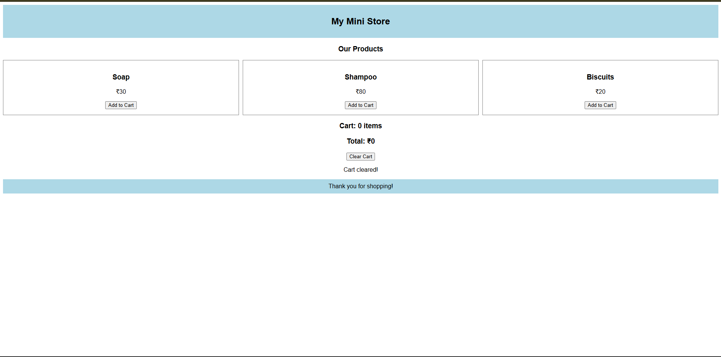

Experiment 2: Form Validation using JavaScript
Suppose that a registration form accepts invalid email and phone number inputs, leading to incorrect data submission.
(a) Analyze the issues in the existing form validation mechanism.
(b) Design input fields for email and phone number with appropriate HTML attributes.
(c) Implement JavaScript validation using Regular Expressions for both email and phone number.
(d) Develop a mechanism to display real-time error messages for invalid inputs.
(e) Evaluate the validation system and suggest enhancements for better user experience and security.

Aim: To design a registration form and implement client-side email and phone number validation using JavaScript regular expressions, HTML attributes, and real-time error messages.
(a) Analyze the issues in the existing form validation mechanism
A registration form may accept invalid email addresses and phone numbers if it does not perform adequate validation.
Common issues include:
- Checking only whether fields are empty.
- Accepting malformed email addresses.
- Allowing phone numbers with incorrect lengths.
- Failing to reject alphabetic characters in numeric phone fields.
- Displaying errors only after form submission.
- Providing unclear error messages.
- Failing to validate input on the server.
These issues can lead to inaccurate user records and a poor user experience.
HTML validation attributes and JavaScript regular expressions can help identify common input errors. However, client-side validation can be bypassed, so server-side validation is also necessary in real applications.
(b) Design input fields with appropriate HTML attributes
The form includes email and phone number fields with suitable labels, input types, placeholders, and required attributes.
Program 2: experiment2.html

<!DOCTYPE html>
<html>
<body>
<h3>Registration Form</h3>
<form onsubmit="return check()">
Email: <input id="email" type="text" oninput="check()">
<span id="e"></span><br><br>
Phone: <input id="phone" type="text" oninput="check()">
<span id="p"></span><br><br>
<button type="submit">Register</button>
</form>

<script>
function check() {
let a = document.getElementById("email").value;
let b = document.getElementById("phone").value;
let x = /^[^\s@]+@[^\s@]+\.[^\s@]+$/.test(a);
let y = /^[0-9]{10}$/.test(b);

document.getElementById("e").innerHTML =
x ? "Valid" : "Invalid email";
document.getElementById("p").innerHTML =
y ? "Valid" : "Enter 10 digits";

return x && y;
}
</script>
</body>
</html> (c) Implement JavaScript validation using regular expressions
Regular expressions are patterns used to check whether an input matches a required format.
Email validation:
JavaScript
const emailPattern =
/^[^\s@]+@[^\s@]+\.[^\s@]{2,}$/;
This pattern checks for text before and after the @ symbol and a domain suffix containing at least two characters.
Phone number validation:
JavaScript
const phonePattern = /^[6-9]\d{9}$/;
This pattern checks for a 10-digit Indian mobile number beginning with a digit from 6 to 9.
The test() method checks whether the input matches the pattern. If the input does not match, the function returns false, and an appropriate error message is displayed.
These expressions provide practical format checks, but they do not verify that an email account or phone number actually exists.
(d) Develop real-time error messages
The input event allows JavaScript to validate fields while the user types.
For example:
JavaScript
email.addEventListener("input", function () {
validateEmail();
});

phone.addEventListener("input", function () {
validatePhone();
});
When an invalid value is entered, the relevant error message appears below the field. When a valid value is entered, the error message disappears.
The form submission event validates both fields before displaying the result.
JavaScript
form.addEventListener("submit", function (event) {
event.preventDefault();

const validEmail = validateEmail();
const validPhone = validatePhone();

if (validEmail && validPhone) {
result.textContent =
"Validation successful!";
} else {
result.textContent =
"Please correct the errors.";
}
});
The preventDefault() method prevents the browser from performing its normal form submission. This allows the example to demonstrate validation without sending or storing user data.
(e) Evaluate the validation system and suggest enhancements
The validation system identifies common formatting errors before the user proceeds. Real-time feedback makes it easier to correct invalid information, while separate error messages help the user identify the field that needs attention.
The following test cases can be used to evaluate the program.
Test case | Input | Expected result
1 | student@example.com | Valid email
2 | studentexample.com | Invalid email
3 | 9876543210 | Valid phone format
4 | 1234567890 | Invalid phone format
5 | 987654321 | Invalid phone length
6 | Empty email and phone | Both fields show errors
7 | Valid email and phone | Validation success message
Further improvements include server-side validation, secure HTTPS communication, phone and email verification, accessible error messages, rate limiting, and protection against automated submissions.
Security note: Client-side validation is intended to improve user experience. It cannot guarantee data integrity because users can disable JavaScript or modify browser requests. All important validation must also be performed on the server.
Result: A registration form was developed using HTML and JavaScript. Regular expressions were used to validate email addresses and Indian mobile number formats, and real-time error messages were implemented.
Conclusion: JavaScript validation helps prevent common input errors and improves the registration experience. Combining HTML attributes, regular expressions, clear error messages, and server-side validation creates a more reliable form.
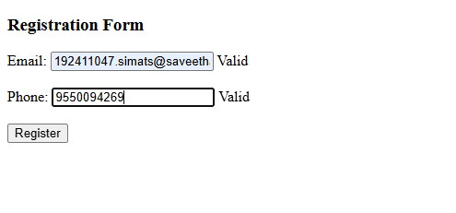

Experiment 3: CSS Layout Debugging
Suppose that a webpage layout overlaps when the browser window is resized, affecting usability.
(a) Analyze the CSS properties responsible for layout overlapping issues.
(b) Examine the role of the CSS box model (margin, border, padding, content) in layout design.
(c) Debug the layout using appropriate positioning techniques (relative, absolute, flex, grid).
(d) Modify the CSS to ensure proper alignment and prevent overlapping during resizing.
(e) Evaluate the corrected layout and suggest best practices for maintaining consistency.

Aim: To analyze CSS layout overlapping problems, understand the CSS box model, and correct webpage alignment using appropriate positioning techniques, Flexbox, Grid, and responsive CSS.
(a) Analyze the CSS properties responsible for layout overlapping
Layout overlapping occurs when webpage elements occupy the same area or extend beyond their available space. It can happen when a webpage is resized or when the content becomes larger than expected.
The common causes are:
- Fixed width: An element with a fixed width may exceed the available viewport width.
- Absolute positioning: Elements positioned absolutely are removed from normal document flow and may overlap other content.
- Fixed height: A container with a fixed height may not accommodate additional text or content.
- Negative margins: Large negative margins can move elements over one another.
- Incorrect z-index: Elements with higher stacking priority may cover other elements.
- Box model errors: Padding and borders can make elements larger than expected when using the default content-box model.
- Improper Flexbox or Grid configuration: Incorrect sizing and minimum-width constraints can cause overflow.
- Unresponsive images: Images that are wider than their containers may create horizontal scrolling.
These problems can be corrected by using flexible layouts, appropriate sizing, responsive breakpoints, and consistent spacing.
(b) Examine the role of the CSS box model
The CSS box model describes how the dimensions of an HTML element are calculated. It consists of four components.
- Content: The actual text, image, or other content inside the element.
- Padding: The space between the content and the border.
- Border: The line surrounding the padding and content.
- Margin: The space outside the border that separates the element from other elements.
Under the default content-box model, the declared width applies only to the content. Padding and borders increase the element's total width.
For example, an element with a content width of 300 pixels, 20 pixels of padding on each side, and a 2-pixel border on each side has a total width of 344 pixels, excluding margins.
Using box-sizing: border-box makes the declared width include content, padding, and border. This makes layout calculations more predictable.
Example:
CSS
* {
box-sizing: border-box;
}

.container {
width: 100%;
max-width: 1100px;
margin: auto;
padding: 20px;
}
This approach helps prevent unexpected overflow and makes responsive design easier to maintain.
(c) Debug the layout using appropriate positioning techniques
CSS provides several layout and positioning techniques.
Technique | Purpose
position: relative | Positions an element relative to its normal position and can establish a containing block for absolute children.
position: absolute | Positions an element relative to its containing block, removing it from normal document flow.
Flexbox | Arranges items in a row or column and controls alignment and distribution.
CSS Grid | Arranges content into rows and columns.
Normal document flow | Places elements naturally according to their HTML structure.
For ordinary webpage content, Flexbox and Grid are generally more suitable than absolute positioning because they adapt more naturally to changing content and screen sizes.
In the following program, CSS Grid is used to arrange the main content and sidebar. A media query stacks them vertically on smaller screens.
(d) Modify the CSS to prevent overlapping during resizing
Program 3: experiment3.html

<!DOCTYPE html>
<html>
<head>
<style>
body { font-family: Arial; }
.box { padding: 20px; background: lightblue; margin: 5px; }
main { display: flex; }
* { box-sizing: border-box; }
@media(max-width: 500px) {
main { flex-direction: column; }
}
</style>
</head>
<body>

<h2>CSS Layout Debugging</h2>
<button onclick="fix()">Fix Layout</button>
<button onclick="reset()">Reset</button>

<main id="layout">
<div class="box">Box 1</div>
<div class="box">Box 2</div>
</main>

<p id="msg">Click Fix Layout to correct the alignment.</p>

<script>
function fix() {
document.getElementById("layout").style.flexDirection = "column";
document.getElementById("msg").innerHTML =
"Layout fixed! Boxes are arranged vertically.";
}
function reset() {
document.getElementById("layout").style.flexDirection = "row";
document.getElementById("msg").innerHTML =
"Layout reset to horizontal.";
}
</script>

</body>
</html>
Explanation of the corrected code
- box-sizing: border-box ensures predictable element dimensions.
- display: grid arranges the main content and sidebar.
- minmax(0, 2fr) allows the main column to shrink within its grid track.
- gap: 20px maintains consistent spacing between columns.
- min-width: 0 prevents content from imposing unwanted minimum widths on grid items.
- max-width: 1100px prevents the main container from becoming excessively wide.
- overflow-wrap: anywhere allows long unbroken text to wrap when necessary.
- The media queries change the two-column layout to a single column when the viewport becomes narrower.
- max-width: 100% prevents images from extending beyond their containers.
These changes make the layout more flexible and reduce the risk of overlap when the browser window is resized.
(e) Evaluate the corrected layout and suggest best practices
The corrected webpage uses CSS Grid to organize content and a sidebar. On wider screens, both sections appear side by side. On narrower screens, the sidebar moves below the main content.
The following tests can be performed:
Test case | Viewport | Expected result
1 | 1280 px | Main content and sidebar appear side by side.
2 | 768 px | Main content and sidebar stack vertically.
3 | 375 px | Content fits within the mobile viewport.
4 | Long text | Text wraps instead of forcing excessive horizontal width.
5 | Different zoom levels | Content remains readable and the layout can reflow.
Best practices for maintaining consistency include:
- Prefer Grid and Flexbox for normal content layouts.
- Avoid fixed heights for containers that hold variable-length text.
- Use responsive widths and images.
- Apply box-sizing: border-box consistently.
- Avoid unnecessary absolute positioning.
- Use media queries for layouts that need to change at narrower widths.
- Inspect overflowing elements using browser developer tools.
- Test keyboard accessibility, text resizing, and different browsers.
Result: The webpage layout was designed and corrected using CSS Grid, responsive media queries, and box-sizing techniques. The corrected layout is intended to prevent content overlap during browser resizing.
Conclusion: Proper understanding of the CSS box model, positioning, Grid, Flexbox, and responsive design techniques helps create stable and user-friendly webpage layouts. Testing at different screen sizes is essential to identify and correct layout problems.

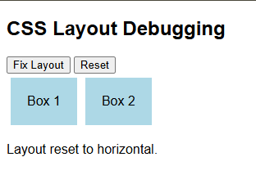

RUBRICS FOR CALCULATION:

Criteria | Weightage | Level 4 – Exemplary | Level 3 – Proficient | Level 2 – Developing | Level 1 – Beginning
Understanding of Concepts | 25 | Demonstrates thorough understanding and effectively integrates multiple concepts/technologies | Good understanding with proper integration of most concepts | Basic understanding; limited or partial integration | Poor understanding; unable to integrate concepts
Experimental Design | 30 | Well-planned, systematic implementation with optimal solution | Correct implementation with minor issues | Basic implementation with errors or inefficiencies | Incorrect or incomplete implementation
Use of Tools | 20 | Effective and advanced use of tools/technologies with proper configuration | Appropriate use of tools with correct execution | Limited or inconsistent use of tools | Incorrect or minimal use of tools
Analysis of Results | 15 | Insightful analysis with accurate interpretation and validation of results | Good analysis with reasonable interpretation | Basic analysis with limited insights | Poor or incorrect analysis of results
Documentation | 10 | Clear, well-structured documentation with diagrams, code, and results | Organized documentation with necessary details | Basic documentation with missing details | Poor or incomplete documentation

